F A I Z U L L A H K H A
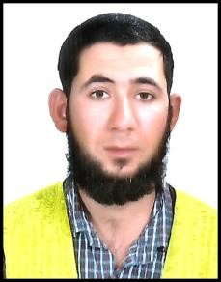Mohallah Boki Khel Kot Ismal Zai P/O Garhi Kapura

N
Tehsil and District Mardan KPK Pakistan
Cell # 0092-345-0758059
Email: faiz0345khan1@gmail.com

Objectives:

To seek a challenging job using my work experience and qualification. I am looking for an opportunity that would help me in build up my skill and enjoy my growth. I am confident that I
Will be able to fulfill my duties in conformity to requirement of the organization.

Personal Information

Father Name : Raza Khan

Date of Birth : 05-01-1992

NIC # : 16101-1811994-3

Nationality : Pakistani Religion : Islam Gender : Male
Domicile : District Mardan KPK

Academic Career

CERTIFICATE/ DEGREE | SESSION | OBT.M/ T.MARKS | UNIVERSITY/BOARD
S.S.C (Science) | 2008 | 523/900 | BISE Mardan
D.A.E (Civil) | 2011 | 2256/3350 | KP BTE Peshawar

Experience Skills
- Work as Road Surveyor in China Railway Construction Corporation Peshawar Karachi motorway M-3(Lahore Abdul Hakeem Section) CPEC project from April 2016 till date.
- Worked as Surveyor at AIED DAHIM ALHAMOUD & PARTNERS Saudi Arabia from 19-10-
2014 to 17-01-2016.
- Worked as Assistant Surveyor at Frontier Works Organization from 1st Oct, 2012 to 30th
Oct 2013.Psc-Torkham Road (N-5) Khyber Agency FATA (QIP) Project.
- Worked as Site Engineer at Janson Construction Company Limited from July 2011 to
January 2012.

Computer Skills

MS Office (MS Word, MS Excel, MS Power Point)
Auto Cad (2D & 3D 2006)
Eagle Point
Internet & Email

Languages

Three Months English Language Course
English, Urdu, Pashto and Arabic

Leisure Activities

Like playing cricket
Football Love swimming
Like listening music
Reading Books & magazine

