Curriculum Vitea

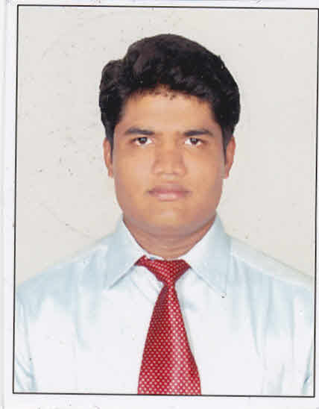
Khaja Basheeruddin Ahmed
8-3-711/5/1 Immamguda
Srinagar colony, Ameerpet
Hyderabad.
E-mail: khajaahmed1503@gmail.com
Phone no: +91-7842824096

EDUCATION:
M.Tech (civil Transportation Engineering)(Roads)
Mallareddy collage of engineering (69%)
Major project (Identification of Vehicular growth and its management on NH-202)
Mini project (Road safety auditing)

B.Tech (civil)
Symbiosis institute of technology & science
Jawaharlal Nehru Technological University
Academic Project Undertaken Estimation and costing of a commercial building. (68.6%)

Board of Intermediate Education, A.P (M.P.C)
Sri Chaitanaya Junior kalasala (66.1%)

Secondary School Certificate
Richmond high school (72%)

Diploma in quantity surveying

JOB EXPERENCE:
Worked as assistant professor in Aurora Engineering college (Jan 2017 – August 2017)

Worked as assistant professor in Symbiosis college of science and technology (Feb 2016 – Dec 2016)

COMPUTER SKILLS:

- Microsoft Office proficient in
MS-Word, Excel, PowerPoint.
- Good Keyboard skills.
- AutoCAD (2D,) 2012
- Primavera P6
SEMINARS:
- Presented a Paper on “Fiber Concrete”, in Muffakham Jah College of engineering and technology and Al Habeeb College of Engineering and technology.
- Presented paper on “Green Buildings” as PPT in our college.

ACHIEVEMENTS:

- Won second prize in model making at Muffakham Jah College of engineering.
- I organize the event and cultural activities at college.
- I won many cricket matches for the college
- I have conducted the Technical Fest in our college.

PASSPORT DETAILS:

Passport No : L1288044
Date of Issue : 15/05/2013
Date of Exp : 14/5/2023
Issued At : Hyderabad

DRIVING LICENSE:
Indian LMV Driving License Number : DLFAP0092662508

DECLERATION:

I, KHAJA BASHEERUDDIN AHMED, hereby declare that the above written particulars are true to the best of my knowledge and belief.

Place: Hyderabad.
With Regards,

(KHAJA BASHEERUDDIN AHMED)

