CURRICULUM VITAE
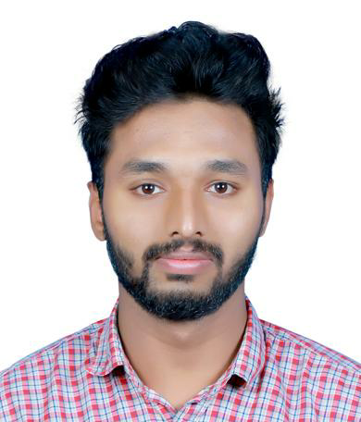

HAMAL K H
Mobile No: +971507981248

Email: hamalkhh@gmail.com

Availability: Immediate

CAREER OBJECTIVE

Diploma graduate with more than two years of experience in the field of mechanical engineering, currently seeking challenging position to exhibit technical skills and knowledge gained through professional education and contribute to the growth of any organization.

WORK EXPERIENCE

BPCL Bharat Petroleum Corporation Limited, Cochin India (August 2014-September 2016) Mechanical Site Supervisor (2 years)
- Managed to take part in the planning and assigning of jobs in the site and also conduct regular inspections.
- Managed to supervise daily activities in the works it including welding, erection of pipes and fabrication and assess daily progress.
- Coordinate with civil and electrical departments for improving performance efficiency and avoiding repetition of jobs.
- Prepare and send daily reports to the site engineer on site performance and report recommendations.
- Attend technical meetings with clients and contractors and managed to incorporate suggestions in the daily working schedule.
- Monitor site performance and identify opportunities for improving performance efficiency and reducing cost.
- Managed to hand over the projects in the prescribed time by proper deployment of labour force.
- Effective and timely requisitioning for resources and services required to ensure uninterrupted workflow.

EDUCATION

- Diploma in Mechanical Engineering from IME INDIA (Institute of Mechanical Engineers India), Cochin, Kerala, India (Graduated 2014).
- Higher Secondary in Science from Kerala State board of Secondary Education Cochin, Kerala, India (Graduated 2012).

PROFESSIONAL SKILLS

- Expertise in supervising of fabrication welding and erection.
- Expertise in engineering drawings.
- Ability to manage people.
- Proficient in handling multiple projects.
- Strong analytical skills and problem solving skills.
- Excellent communication skills
- Expertise in drafting engineering reports

COMPUTER SKILLS

- Professional in Microsoft Word, PowerPoint, Excel and Outlook.
- Experience in various versions of Windows and Linux.

PERSONAL INFORMATION

Date of Birth : 14 July 1994
Language : English, Hindi, Malayalam, Tamil
Nationality : Indian
Marital Status: Single
Religion : Islam Muslim
Passport details: Number: M1821805
:Date of Expiry: 01/09/2024
Visa status: On visit visa valid till 25th February 2018

DECLARATION

I do hereby declare that all the information given above is true to the best of my knowledge and belief.
HAMAL K H

