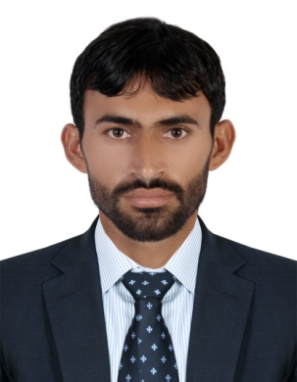
AMAN UL ATEEQ

CONTACT NO +971-507321490

Email: imateeq90@gmail.com

CAREER SUMMARY OBJECTIVE
To Achieve high career growth through a continuous process of learning for achieving goal & keeping myself dynamic in the changing scenario to become a successful professional and leading to best opportunity. And willing to work as Civil and in the reputed construction industry.

WORKING EXPERIENCE
- PROJECT | - DURATION
- Dubai Water Canal | - 1 Year
- AL Furjan Road Structure | - 1 Year
- AL Khawaneej Sewerage & Drainage System | - 6 months

EDUCATIONAL CREDENTIALS

DIPLOMAS | Institute
DAE (CIVIL) | BOARD OF TECHNICAL EDU PESHAWAR
QUANTITY SURVEY | TRADE TESTING BOARD PESHAWAR
HSSC  SSC | BISE KOHAT  BISE KOHAT

FIELD OF INTREST: BUILDING AND ROAD CONSTRUCTION

BINNAWI GENERAL CONTRACTING LLC DUBAI
- 
- 
- 
- 
- 
- 
- 
- 
- 
- 
- 
- 

SHAZS CONSULTANT PAKISTAN

- 
- 
- 
- 
- 
- 
- 
- 
- 
- 

PERSONAL
- Profile: Male, Age 28
- Nationality: Pakistani
- Language: English, Urdu, Pashto

PROFESSIONAL COURSES /CERTIFICATIONS
- AUTOCAD
- CIVIL 3D
- MS OFFICE

Summary | I am Diploma of Associate Engineer 6 year experience at construction companies in UAE and Pakistan I worked in different projects during my careers I.E Roads and building.

ADDITIONAL SKILLS
- Technically competent in using land measurement tools and equipment’s
- Excellent mathematical, logical, and analytical skills
- Expert in MS Office, and AutoCAD, and excellent documentation skills
- Knowledge of GPS equipment computer software applications for land survey
- Strong ethical standards and abilities to develop and implement strategic planning
- Flexible in traveling to the sites located at near and far places
DECLARATION
I here certify that above information are true and correct to the best of my knowledge.

sssssshamSsahssssShammalnbhnb bshamsher
ATEEQ

