Curriculum Vitae
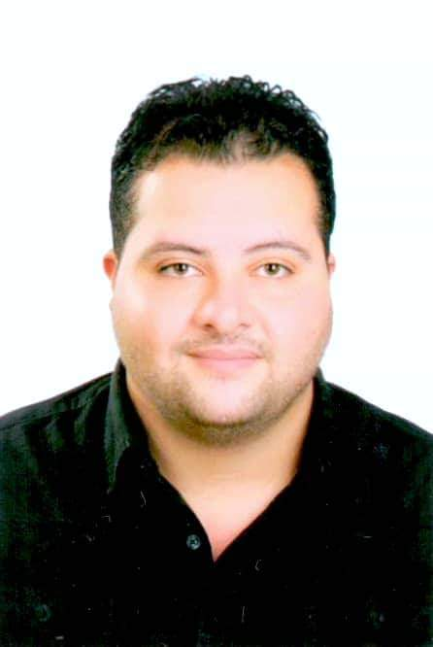

Name: Mohamed Eslam Mahmoud Emam
Nationality: Egyptian
Married Status: Married
Birth Date: MAY 06, 1989
Mobile Phone: +971503070554
E-mail: Mohamed.eslam.1812@gmail.com

EDUCATIONAL BACKGROUND
Bachelor of Engineering, I had graduated from Mansoura University, Faculty of
Engineering, Oct 2014
CARRER OBJECTIVES
To have responsible position in a dynamic organization where I may enhance and practice the knowledge and the skills I acquired and to provide an opportunity for my personal advancement while making an indisputable contribution to the growth of the organization.
Graduation Project
My graduation project was about Sanitary Engineering Project, my grade was (Excellent).
WORK EXEPERIENC

- Site Engineer at (Rawabit El Hamroor Co. Second rating company in KSA) Supervising on Asphalt paving and lighting project
From (DEC.2014 till OCT. 2017).

Work Description
- Site Supervision
- Preparation of Program of Works
- Preparation of Bill Materials
- Preparation of Bar Bending Schedule

- Site Engineer at (Al Asphalt roads construction in united Arab emirates ) Supervising on Asphalt paving and lighting project in Alrahmaniya 2 in Sharjah
From (NOV. 2017 till FEB. 2018).

Work Description
- Site Supervision
- Preparation of Program of Works
- Preparation of Bill Materials
- Preparation of Bar Bending Schedule

- Site and Technical Engineer at ARKAD CO. in Cairo Supervising on asphalt and landscape at Porto projects
from (MAR.2018 till DEC. 2018).

Work Description
- Site Supervision
- Preparation of Program of Works
- Preparation of Bill Materials
- Preparation of Bar Bending Schedule

COURSES
- AutoCAD
- Microsoft Office packages (Word, Excel & PowerPoint).
- Operating system: MS Windows
PROFESSIONAL SKILLS
- Communication
- Listening
- Self-Control
- Positivity
- Conflict Resolution
- Relationship building
- creativity
- willingness to learn new skills
LANGUAGE
- Arabic is mother language
- English

