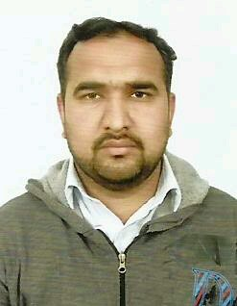

Village & Post office Sagri Dina Distt Jhelum.

Email: Taimoorsagri@gmail.com

Mobile: 0092-3118521333

**MUHAMMAD TAIMOOR SULTAN**

# OBJECTIVE

To use my professional skills in a motivating and competitive environment where interaction with the best will help to achieve goals of the organization on one hand and to attain expertise in my potential abilities on the other.

# PERSONAL STATEMENT

I am a individual and like the challenging environment to accomplish with excellence by leading an efficient teamwork even in a high-pressure environment.

# PERSONAL INFO

Father Name : Sultan Mehmood

Date of Birth : 17-01-1983

Passport No. : BA5771363

Religion : Islam

Nationality : Pakistani

# ACADEMIC QUALIFICATIONS

|  |  |  |
| --- | --- | --- |
| Qualification | Year | Board / University |
| **Matric** | 1998 | Rawalpindi |

h

# work Experience

KO

* I have UAE License #8.and also 8 years Experience AlHijaz Electromechanical Company LLC Dubai and Eagle Electromechanical Company LLC Sharjah as a Heavy Equipment Operator ( JCP-Wheel Excavator-Excavator+Shawal )
* 1 Years Experience as a Electrician Fuji Foundation College Jhelum Pakistan.
* 6 Month Experience as a Computer Course.



* Foreign Languages: English, Arabic. Hindi
* Local Languages: Urdu , Punjabi .