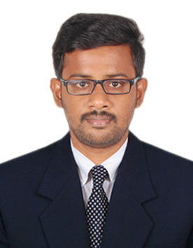

Name : SARATH KUMAR GUNASEKARAN Nationality : Indian
Date of birth : 18-09-1993

E-mail : sarath_15gsk@rediff.com
UAE Mobile No : +971 559241474
Notice period : Ready to join immediately

Career Objective

To pursue a career that gives a challenging and creative position in a fast-paced and learning-oriented environment for developing my skills and teamwork abilities to contribute the same for the betterment of the organization.

Educational Qualification

- Master of Technology in Remote Sensing at Anna University (Chennai, India) in the year
2014- 2016
- Bachelor of Engineering in Civil Engineering at Anna University (Chennai, India) in the year 2010-2014

Professional Experience

- Name of the company: Portsaeed Transport and Building contracting llc
- Period of work: 1. 3year s (02/03/2017 to 17/06/2018)
- Position: Site Civil Engineer
- Projects:
- Dubai Wholesale city- March 2017 to October 2017.
- Bulk Earthworks- Al Layan Industrial area, Phase 1-November 2017 to till date.
- Job Responsibilities:
- Site implementation of Design plan.
- Prepares periodic reports summarizing progress of activities for higher-level management and consultant.
- Responsible for following up the Request for Inspection (RFI) responses with the consultant.
- Coordinating with Consultant Representative for the In-situ tests.
Academic Project Profile

- Evaluation of Mining Related Environmental Impacts of Limestone Mining in the Ariyalur area using Remote Sensing (M.Tech.2016)
- Study on the Effect of Geo-Grids on layered soils (B.E. 2014)

Publications

- Sarath Kumar. G and Dr. Nallapa Reddy. A. (2016). Application of Remote Sensing to assess Environmental impact of Limestone mining in the Ariyalur district of Tamilnadu, India. Journal of Geomatics, Vol.10 No.2, Oct 2016, pp.158-163.

Technical Skill Set

- Expertise on Auto Cad, STAAD.Pro, Arc GIS, Erdas Imagine.

In-Plant Training

- Undergone In-Plant Training at “Chennai Metropolitan Development Authority (CMDA)”, Chennai on “Detailed Development Plan and Master Plan Preperation” for a period of one month from 15-06-2015 to 13-07-2015.
- Undergone In-Plant Training at “IVRCL”, Chennai on “Mint Grade Seperator Project” from 21-06-2012 to 22-06-2012.

Memberships

- Society of Engineers-UAE. (Id:50512)
- UAE Driving License.
Declaration

I hereby declare that the information furnished above is true to the best of my knowledge and my objective to work in your organization shall be fulfilled if I’m selected.
Your’s faithfully,
SARATH KUMAR GUNASEKARAN `

