RESUME
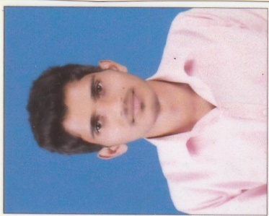
Mohammad Musthafa
S/o Zakariya B
D.No: 1-446, kalasaguri house,
Addoor Post & Village,
Mangalore-574145
E-mail: Muhammadmusthafa31@gmail.com
Mob. No: +919611556869

CARREER OBJECTIVE

I define myself as a confident, creative person who constantly looks forward for improvisation. Dedication and determination is my policy towards work. Provided an opportunity I promise I would work with absolute sincerity and give my best to the organization.

ACADEMICS

- Completed My Auto Cadd,3ds max, Revit Architecutre in CADD Centre, Mangalore (2015-2016)

- Completed My Diploma in Civil Engineering Education in Western Institution of Technology, Mangalore securing 74% (2014-2015)

- Completed My SSLC in Govt Composite High School, Kinikambla, Mangalore securing 49%

WORK EXPERIENCE

- Worked as coffee server in cafe coffee day Manglore for 6 months
- Worked as site engineer in krishnapura Manglore for 1 year
- Currently working in Manglore as site superviser
PERSONAL SKILLS

- Good communication Skills.
- Ability to work and contribute effectively in a team.
- Effectively listening and presenting capability.
- Basic Computer knowledge (MS-Word, MS-Excel, MS access and Power Point Presentation)
- Knowledge about basic electronic instruments.
AREAS OF INTEREST

- Accounting
- Finance
- Management
PERSONAL INFORMATION

Name : MOHAMMAD MUSTHAFA
Father’s Name : ZAKARIYA B
Date of Birth : 21/10/1995
Gender : Male
Religion : Muslim
Nationality : Indian
Languages Known : English, Hindi, Kannada,Local Language & .
Malayalam.
PASSPORT NO : P3895557
DATE OF ISSUE : 17/08/2016
DATE OF EXPIRE : 16/08/2026
PLACE OF ISSUE : BANGALORE
STRENGTH

Diversified experience and expertise in excellent verbal and written communicational skills, self-confidence, hard-working, optimistic, good grasping ability, quick learner, commitment and dedication for professional and excellence.

DECLARATION:

I hereby declare that the above information is true to the best of my knowledge.

PLACE: MANGALORE YOURS FAITHFULLY
DATE:
Mohammad Musthafa

