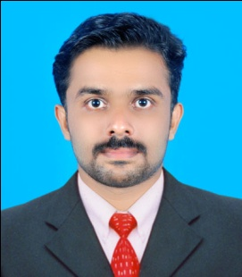
NANDU S
KERALA
INDIA
Mob : 056-9412185
UAE Phone: 050-5249504
E-Mail: nandoosnadanam@gmail.com

OBJECTIVE

Ability to get work executed within desired time schedules. Willingness to learn and implement newly invented technology in the field of engineering and construction.

WORK EXPERIENCE

Working as Site Engineer for last three years

One year experience in Parthi Group

Two year experience in Theruvath Builders .

RESPONSIBILITIES
- Taking joint measurements of retaining wall, Drain.
- supervising works of drain, building construction & compound wall
- Making of Daily, Monthly Progress Report & monitoring the progress.
- Making of Daily Labor Report.
- Involved in Making of Baseline Program.
- Checking of built drawings.
- Quality evaluation of materials supplied to site.
- Monthly Presentation.
- Coordination with client, consultant & vendors on various issues.

TECHNICAL QUALIFICATIONS

Diploma in Civil engineering (INDIAN CIVIL ENGINEERS)

AUTO CAD, 3D MAX from INFOTECK KOLLAM

COMPUTER KNOWLEDGE

M S Office, AutoCAD & 3D Max.

PERSONAL DETAILS

Name : Nandu S
Date of Birth : 17th January 1994
Gender : Male
Marital Status : Single
Nationality : Indian
Languages Known : English, Malayalam ,Hindi and Tamil
Passport Number : M0547537
Validity : 31-07-2014 to 30-07-2024
Visa status : Visit Visa
Mobile No : 056-9412185

PERSONAL STRENGTHS

- Honest and energetic with solid commitment to follow through.
- Enjoy working in team effectively
- Adapt easily to new environments

EXTRACARICULAR ACTIVITIES

- Participated in kabadi competition in college level.
- Participated in long jump.
- Voluntary blood donator.

HOBBIES
- Playing cricket
- Driving
- Listening Music

DECLARATION

I hereby declare that all the above information is true to the best of my knowledge and belief.
Nandu S.

